

MOBILE APPLICATION TO SECURE TENURE PILOT

PROJECT (MAST)

User Manual for the Mobile Application (v.2.2)

APRIL 2016

This document was produced for review by the United States Agency for International Development. It was initially prepared by Cloudburst Consulting Group, Inc. for the Evaluation, Research, and Communication (ERC) Task Order under the Strengthening Tenure and Resource Rights (STARR) IQC.

Prepared for the United States Agency for International Development, USAID Contract Number AID- OAA-TO-13-00019, Evaluation, Research and Communication (ERC) Task Order under Strengthening Tenure and Resource Rights (STARR) IQC No. AID-OAA-I-12-00030.

Implemented by:

Cloudburst Consulting Group, Inc. 8400 Corporate Drive, Suite 550

Landover, MD 20785-2238

Mobile Application to Secure Tenure Pilot Project (MAST)

User Manual for the Mobile Application

Version 2.2

APRIL 2016

**DISCLAIMER**

The authors' views expressed in this publication do not necessarily reflect the views of the United States Agency for International Development or the United States Government.

TABLE OF CONTENTS

1. DOCUMENT OVERVIEW 3

2. ABOUT THE MAST APPLICATION 3

3. INSTALLATION STEPS 4

4. LOGIN 4

5. MAP VIEWER 6

5.1 LAYER MANAGER 7

5.2 GPS 8

5.3 GET LOCATION CO-ORDINATES 9

5.4 MEASURE 10

5.4.1 CALCULATE DISTANCE 11

5.4.2 CALCULATE AREA 12

5.4.3 MEASURE POLYGON AREA 13

5.4.4 MEASURE LINE LENGTH 13

5.5 PARCEL INFO TOOL 14

5.6 ADD/VIEW BOOKMARK 15

5.6.1 ADD BOOKMARK 15

5.6.2 VIEW BOOKMARK 16

6. DOWNLOAD DATA 17

7. DOWNLOAD CONFIG 18

8. VERIFY DATA 19

8.1 PENDING 19

8.1.1 VIEW MAP 20

8.1.2 VIEW ATTRIBUTES 21

8.1.3 MARK AS VERIFIED 22

8.2 VERIFIED 23

8.3 FINAL 23

9. CAPTURE DATA 24

9.1 LAYER MANAGER 25

9.2 ZOOM TO CURRENT LOCATION 26

9.3 ADD BOOKMARK 27

9.4 VIEW BOOKMARK 27

9.5 ADD FEATURE 28

9.5.1 DRAW POLYGON 28

9.5.2 CAPTURE POLYGON BY GPS 29

9.5.3 SNAPPING 29

9.6 CAPTURE ATTRIBUTES 31

9.6.1 New Claim 32

9.6.2 Existing Right 51

9.6.3 Unclaimed 53

9.6.4 Disputed Claim 55

8.7 EDIT SPATIAL 58

8.8 DELETE FEATURE 60

9. REVIEW DATA 62

9.1 DRAFT LIST 63

9.1.1 EDIT SPATIAL 64

9.1.2 EDIT ATTRIBUTE 65

9.1.3 DELETE ENTRY 66

9.1.4 MARK AS COMPLETE 67

10. UPLOAD DATA 69

11. USER PREFERENCES 70

11.1 CHANGE LANGUAGE 71

11.2 CONFIGURE AUTO SYNC 72

11.3 CONFIGURE MAP SETTINGS 73

11.3.1 SNAPPING 73

11.3.2. LABELING AND VERTICES 74

12. LOGOUT 75

# DOCUMENT OVERVIEW

This document intends provides guidelines for MAST mobile application users (Trusted Intermediaries and Adjudicators), for usage of MAST mobile data capture application.

This mobile data capture application has been designed to work on Android based hand-held devices only and enables the field users to capture data of parcels (spatial units) in the field along with parcel attributes and multimedia information.

Pre-requisite:

* 1. Android application (apk) file should be installed on the device.
  2. Internet connectivity should be available to download the data before initiation of data capturing work.

# ABOUT THE MAST APPLICATION

The key objective of MAST is to provide a framework for capturing land rights information using a participatory approach. This framework provides a suite of applications to support the collection and management of land rights information with following key components:

**Mobile Data Capture Application** – The mobile data capture application is an Android-based mobile application to capture land rights information (spatial, alphanumeric and multimedia) on mobile devices in field.

The mobile application is able to conduct data collection work without being connected to a central cloud-based server in offline mode. Data will be collected and stored on users’ handheld devices and once the user is within the influence region of the internet, where data could be synced, the information will be packaged and sent back to the server.

**Land Rights Data Management Infrastructure Application** – Data collected on mobile devices will be transferred to a cloud-based land rights Data Management Infrastructure application which will provide tools to ingest, manage and store data of land rights information. It will also provide reporting components so that required land rights reports can be generated.

This document provides details of the mobile component of the MAST application.

# INSTALLATION STEPS

Steps to install Application in Mobile and configuration of Spatial Data:

* 1. Copy mast.apk in the device
  2. Tap on the app to install the application
  3. Login into the application to create necessary folders/db
  4. Copy the test_vector.mbtiles file into \MTP\spatialdata folder

# LOGIN

This functionality allows authorized users to login into the application.

**Steps:**

* 1. User provides valid User Name and Password
  2. Enter URL of the server
  3. 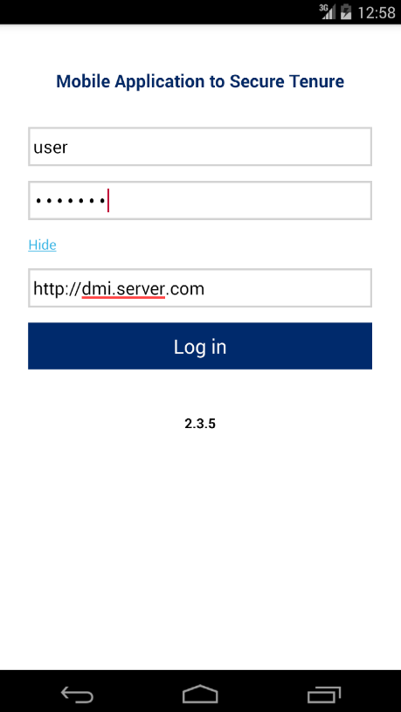Click on ‘Login’ button
  4. Application will open up homepage of application
  5. 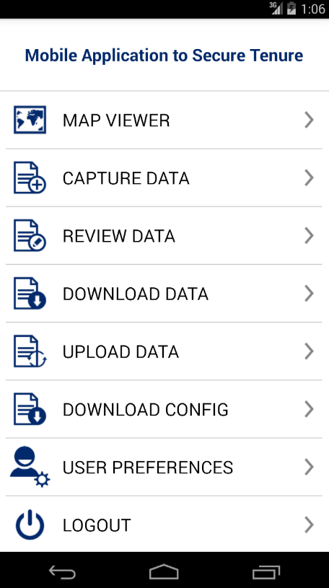Following functionalities are visible:
     + Map Viewer
     + Capture Data
     + Review Data
     + Download Data
     + Upload Data
     + Download Config
     + User Preferences
     + Logout

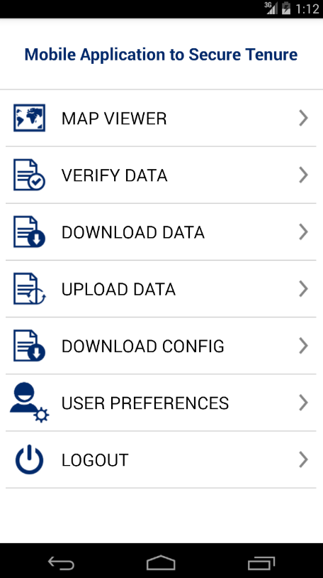**Note – If ‘Adjudicator’ user logs in into MAST,**

**the following functionalities are visible:**

* + - Map Viewer
    - Verify Data
    - Download Data
    - Upload Data
    - Download Config
    - User Preferences
    - Logout

# MAP VIEWER

This functionality allows authorized user/s to view spatial data of parcels and download the base map. Overall, map viewer will display following data layers:

* + Base map (Satellite data downloaded from server)
  + Google base map
  + Collected parcel data (if collected by the user)

This functionality provides following facilities:

* + 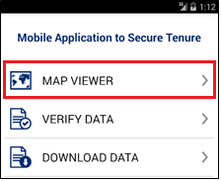View Base Data on map
  + Capture Spatial Data
  + Review Captured Data
  + Navigation Tools
  + Mapping Tools
* Zoom to location
* Enter X and Y coordinates
* Measure
* Info

**Steps:**

1. Click on ‘Map Viewer’ option available on home page
2. Application will open up Map Viewer. Following tools are available with map viewer:
   * Layer Manager

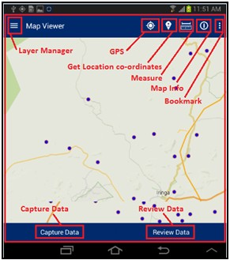

* + GPS
  + Get Location co-ordinates
  + Measure
  + Parcel Info (Map Info)
  + Bookmark
  + Capture Data
  + Review Data

## LAYER MANAGER

This functionality provides the listing of layers configured for the selected project. The user selects On/Off to display a particular layer from the Layer Manager to view on the map.

**Steps:**

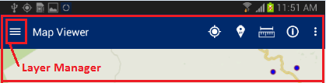

* + 1. Click on Layer Manager option available on top left

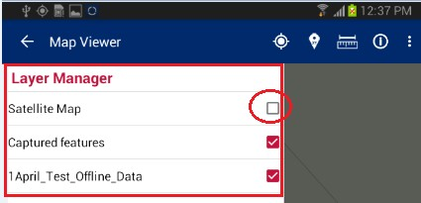

* + 1. List of layers configured for the selected project will be displayed along with a check box. Check/Uncheck the checkboxes on Layer Manager to show/hide a particular layer on the map

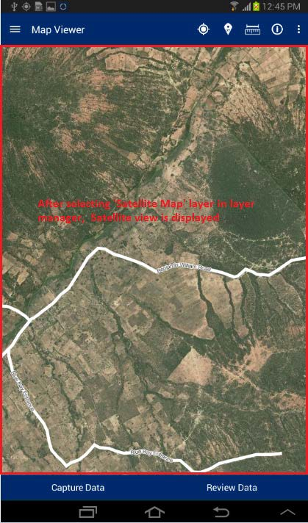

* + 1. Selected layer will become available on map

## GPS

This functionality allows the user to navigate on the map to the current location.

**Steps:**

* + 1. Tap on ‘GPS’ option available on top right
    2. Map will navigate to the current location

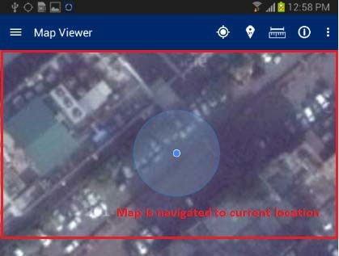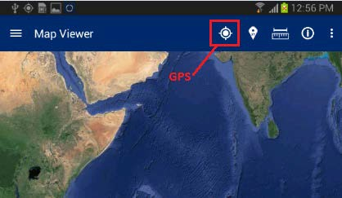

## GET LOCATION CO-ORDINATES

This functionality allows the user to get coordinate values of specified location of map.

**Steps:**

* + 1. Tap on ‘Get location Co-ordinates’ option available on top right

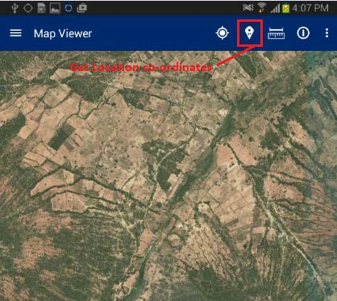

* + 1. Click on map

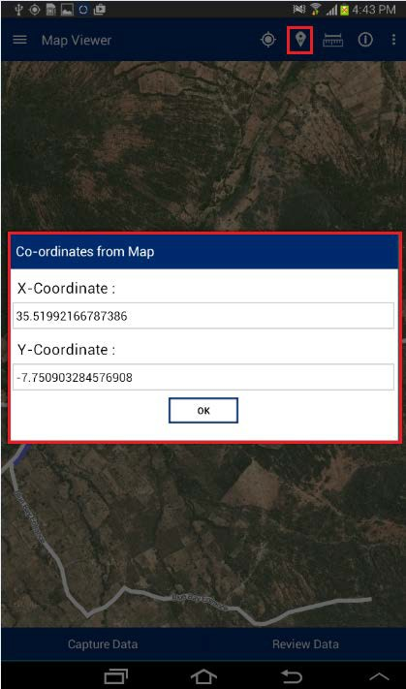

* + 1. ‘Co-ordinates from Map’ dialogue box will be displayed with coordinates of location specified by click on map

## MEASURE

This functionality allows the user to measure the area of any polygon, length of any line or the distance between two points on the map.

**Steps:**

1.

Tap on ‘Measure’ option available on top

right

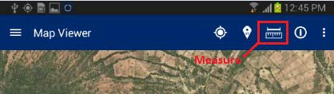

2.

‘Select feature to measure’ dialogue will be

displayed with following options –

* Calculate Distance
* Calculate Area
* Measure Polygon Area
* Measure Line Length

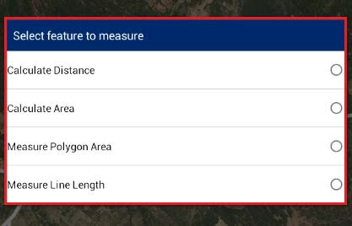

### CALCULATE DISTANCE

This functionality allows the user to calculate the distance between two or more subsequent points on map.

**Steps:**

1.

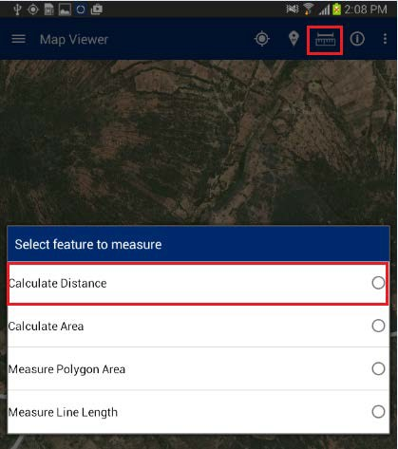

Tap on ‘Measure’ option available on top right

Select ‘Calculate distance’ option

2.

3.

Click on map to specify at least two points

Application will calculate distance and display it on top right of application

4.

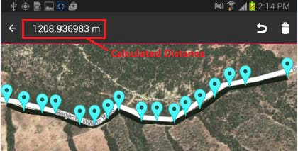

### CALCULATE AREA

This functionality allows the user to calculate the area of a polygon by specifying it on map.

**Steps:**

1.

Tap on ‘Measure’ option available on top right

Select ‘Calculate Area’ option

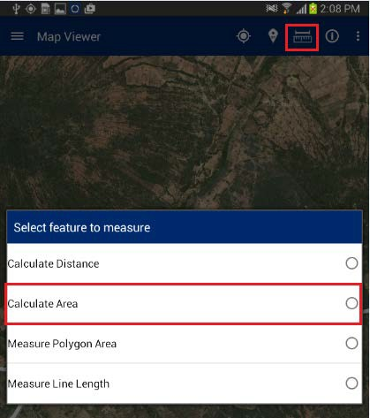

2.

3.

Click on map to specify at least three points

Application will calculate area and display it on top right of application

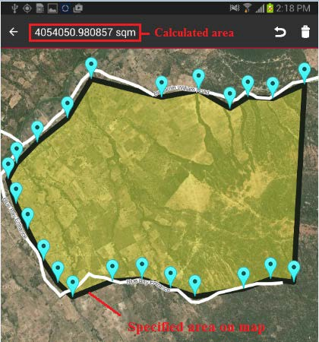

4.

### MEASURE POLYGON AREA

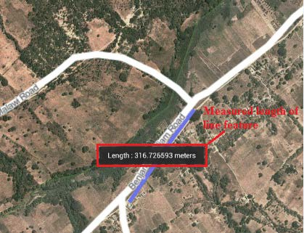

This functionality allows the user to calculate the area of the existing polygon feature by specifying it on the map.

**Steps:**

* + - 1. Tap on ‘Measure’ option available on top right

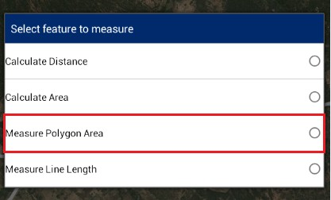

* + - 1. Select ‘Measure Polygon Area’ option

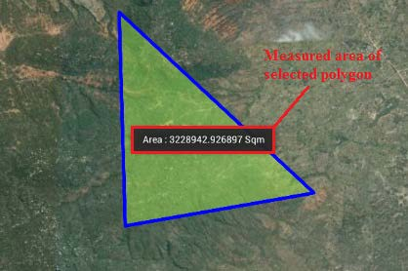

* + - 1. Click on existing polygon feature map
      2. Application will calculate area and display it on the map only

### MEASURE LINE LENGTH

This functionality allows the user to calculate the length of an existing line feature by specifying it on the map.

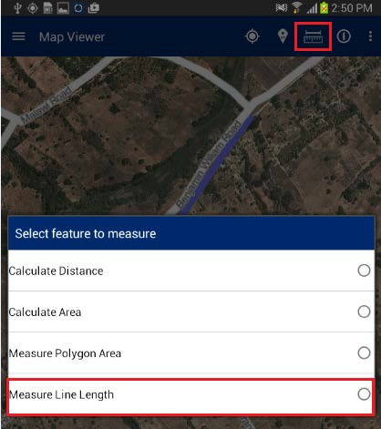

**Steps:**

* + - 1. Tap on ‘Measure’ option available on top right
      2. Select ‘Measure Line Length’ option
      3. Click on existing line feature map
      4. Application will calculate length and display it on map only

## PARCEL INFO TOOL

This functionality allows the user to view the attribute details of any spatial feature which is already created on map.

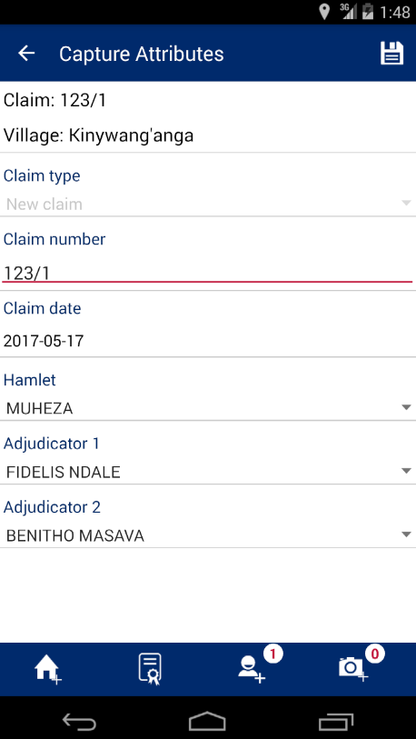**Steps:**

1. Navigate to existing feature on map;
2. tap on ‘Parcel Info’ option available on top
3. Right Click on feature on map
4. Attribute details of specified feature will be displayed

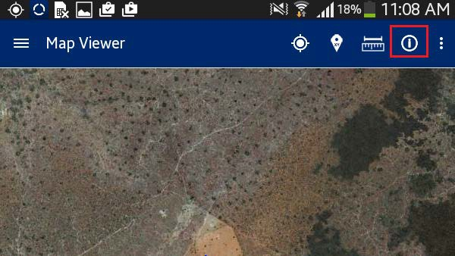

## ADD/VIEW BOOKMARK

This functionality allows the user to save a particular area of interest of on the map canvas for future reference. It also facilitates user to navigate a selected bookmark.

**Steps:**

1. Tap on ‘Add/View Bookmark’ option available on top right

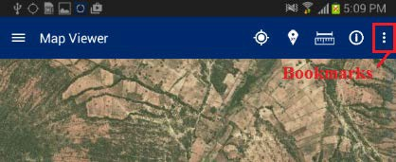

1. Application will display two options:

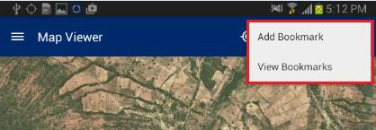

* + Add Bookmark
  + View Bookmark

### ADD BOOKMARK

This functionality allows the user to save a particular area of interest on the map canvas and save for future reference.

**Steps:**

* + - 1. Click on ‘Add Bookmark' option

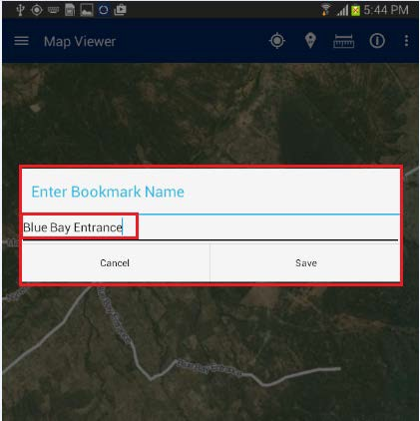

* + - 1. Enter Bookmark dialogue box will be displayed
      2. Enter desired name in input box
      3. Click on ‘Save’ button
      4. Bookmark will be saved with entered name and will become available in ‘Select Bookmark' dialogue

### VIEW BOOKMARK

This functionality allows the user to navigate a selected bookmark.

**Steps:**

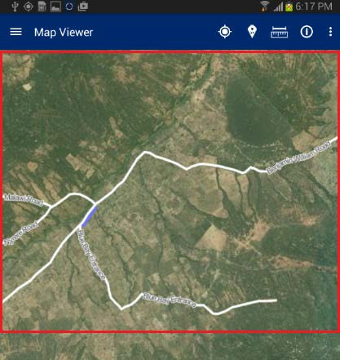

1. Click on ‘View Bookmark' option
2. ‘Select Bookmark' dialogue box will be displayed with list of all bookmarks available
3. Select required bookmark
4. Map will navigate to the location saved with selected bookmark

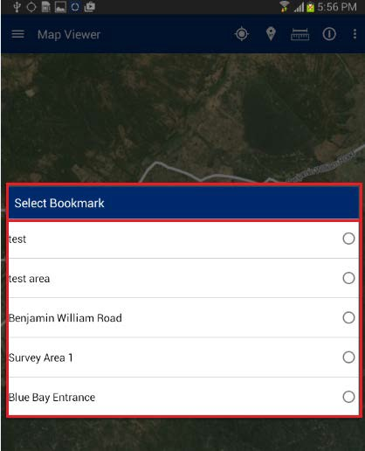

# DOWNLOAD DATA

This functionality allows the user to download all claims, collected and loaded on the server by para-surveyors. These claims can be further used for viewing and snapping when creating new claims. If you open map viewer or start data capturing, all downloaded claims (parcels) will be displayed.

To download data, the mobile device should be in connected mode, i.e. internet should be available in device.

**Steps:**

1.

Click on ‘Download Data’ option available in homepage

Application will connect to the remote server and download required data

2.

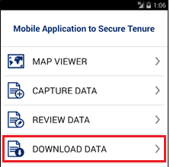

3.

Once Data Download is completed, an acknowledgement message will be displayed, indicating its success.

# DOWNLOAD CONFIG

This functionality allows the user to download configuration information and base data (satellite imagery and vector data which will be used as reference for the data collection process) on the device. To download configuration, the mobile device should be in connected mode, i.e. internet should be available in device.

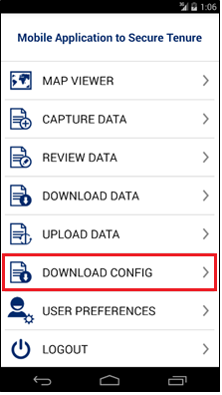**Steps:**

1.

Click on ‘Download Config’ option available in homepage.

Application will connect to the remote server and download required configuration.

2.

1. Once configuration downloading is finished,

you will get appropriate message.

# VERIFY DATA

This functionality allows an Adjudicator user to verify and approve the parcel as completed and synced by Trusted Intermediaries in the field.

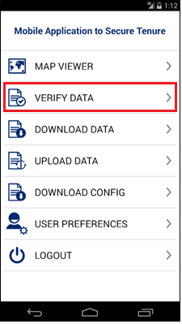**Steps:**

* 1. ‘Adjudicator’ user logs into the application
  2. Application will open up homepage of application.
  3. Following functionalities are visible:
     + Map Viewer
     + Verify Data
     + Download Data
     + Upload Data
     + Download Config
     + User Preferences
     + Logout
  4. Click on ‘Verify Data’ option available in Home page
  5. Verify Data form will be displayed with following lists:

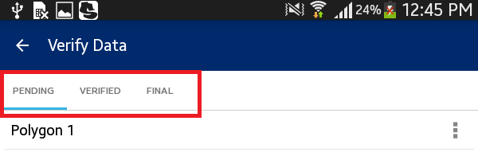

* + - Pending
    - Verified
    - Final



## PENDING

The ‘Pending’ list displays all the parcels that are pending verification by the user. The following actions can be performed on a parcel which is in the pending list:

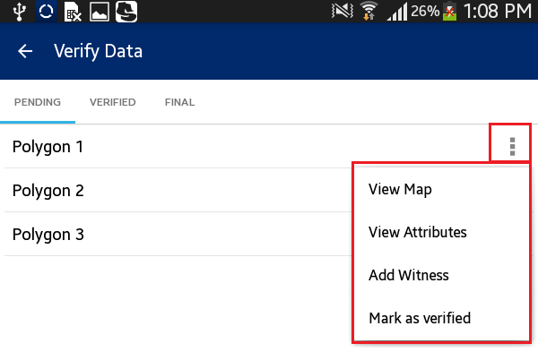

**Steps:**

* View Map
* View Attributes
* Mark as Verified
  + 1. Click on ‘Action’ option available with parcel record in ‘Pending’ list
    2. List of available possible actions will be displayed
       - View Map
       - View Attributes
       - Mark as Verified



### VIEW MAP

This functionality allows the user to edit spatial data.

**Steps:**

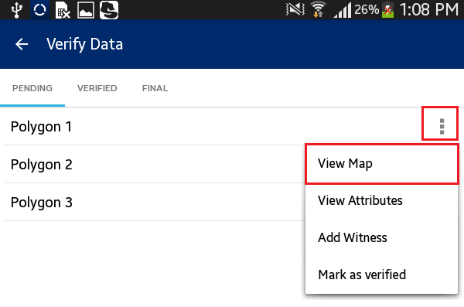

1.

Click on ‘View Map’ option

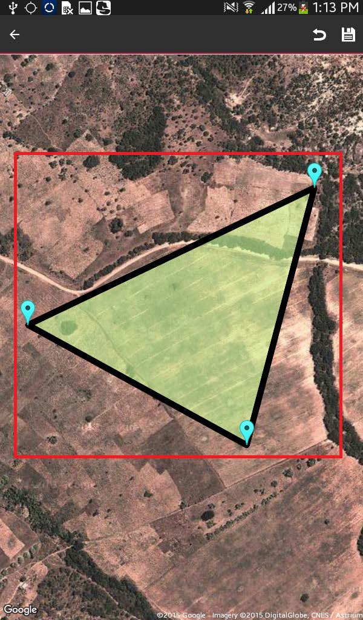

2.

User will navigate to the map and corresponding

feature will be available in edit mode Select node/vertices by long pressing the node/vertices and edit the same

Click on ‘Save’ option

Application will save updated spatial feature

3.

4.

5.

**Note: In case feature is not visible, click on back arrow button on left hand top of screen. Click on Capture Spatial data icon. Application will open up Layer Manager. Switch on Captured Features layer.**

### VIEW ATTRIBUTES

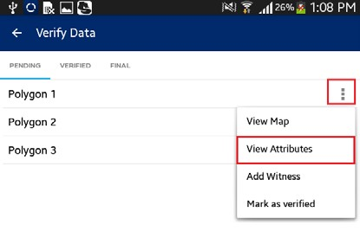

This functionality allows the user to view attribute data of a spatial unit.

**Steps:**

* + - 1. Click on ‘View Attributes’ option



* + - 1. The user will navigate to the ‘Capture Attributes' form and attributes of corresponding feature will be available in read-only mode

### MARK AS VERIFIED

This functionality allows the user to mark a parcel as

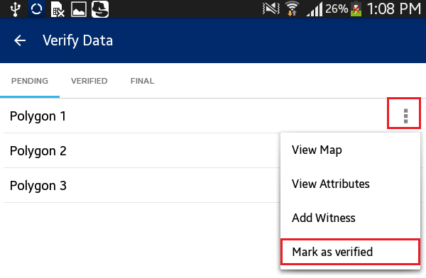

`Verified.”

**Steps:**

* + - 1. Click on ‘Mark as Verified’ option

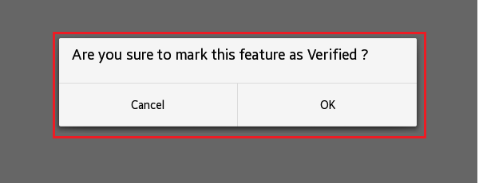

* + - 1. Application will display a confirmation message along with ‘Cancel’ and ‘OK’ button
      2. Click on OK button
      3. Parcel will be verified. It will be removed from the ‘Pending’ List and will become available in the ‘Verified’ List

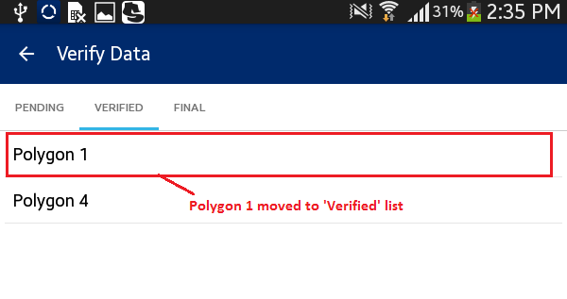

## VERIFIED

‘Verified’ list displays all the parcels that have been marked as verified by the user.

**Steps:**

* + 1. ‘Adjudicator’ user logs into the application



* + 1. Application will open up homepage of application
    2. User clicks on ‘Verify Data’ option available in homepage
    3. Tap the device
    4. 'Verified list' will be displayed

## FINAL

‘Final’ list displays all the parcels that have been marked as final in web application.

**Steps:**

* + 1. ‘Adjudicator’ user logs into the application

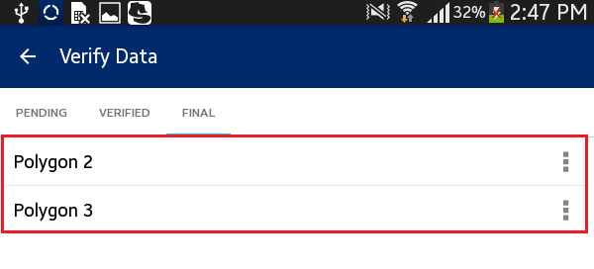

* + 1. Application will open up homepage of application
    2. User clicks on ‘Verify Data’ option available in homepage
    3. Tap the device
    4. 'Final list' will be displayed
    5. Click on ‘Action’ option available with parcel record in ‘Final’ list

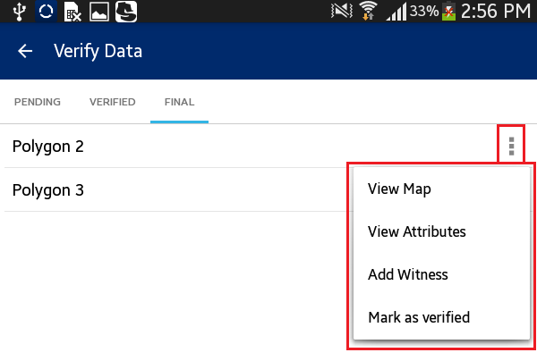

* + 1. List of available possible actions will be displayed:
       - View Map
       - View Attributes
       - Mark as Verified

# CAPTURE DATA

This functionality allows authorized user/s to capture spatial data of parcels on map. This functionality allows users to: Capture new claims, edit claims, delete claims, measure and view info of selected feature.

**Steps:**

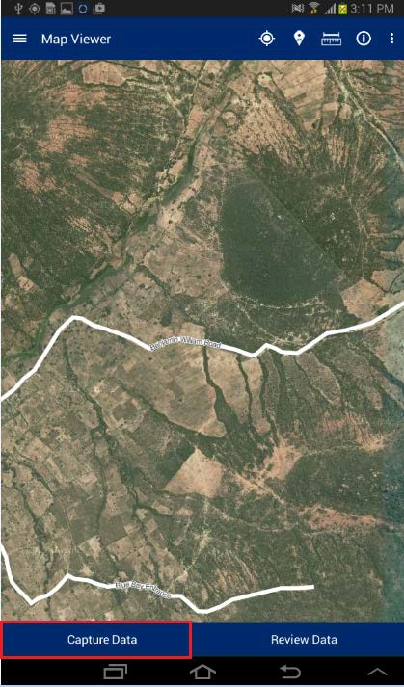

* 1. Click on ‘Capture Data’ button available in Map Viewer

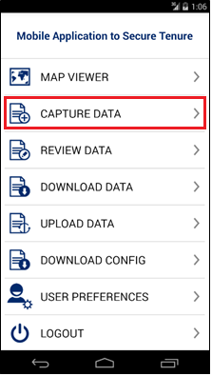

**Note: User can navigate directly to ‘Capture Data’**

**functionality by clicking on ‘Capture Data’**

**option available in homepage.**

* 1. Application will open ‘Capture Data’ window. The following tools are available with the ‘Capture Data’ window:

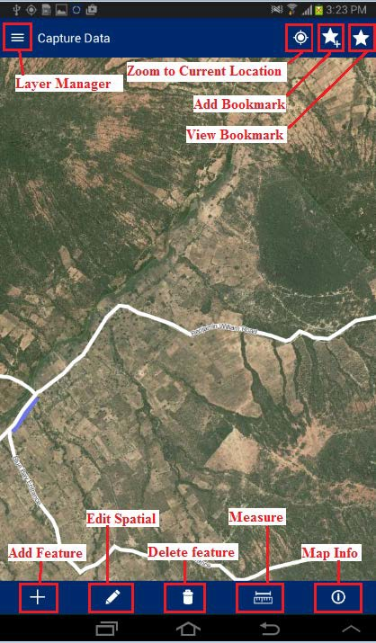

* Layer Manager
* Zoom to Current Location
* Add Bookmark
* View Bookmark
* Add Feature
* Edit Spatial
* Delete Feature
* Measure Tool
* Map Info



## LAYER MANAGER

This functionality provides the listing of layers configured for the selected project. User can select On/Off display of a particular layer from the Layer Manager to view on the map.

**Steps:**

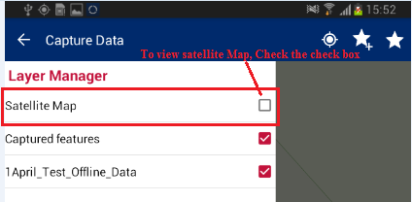

* + 1. Click on `Layer Manager’ option available on top left

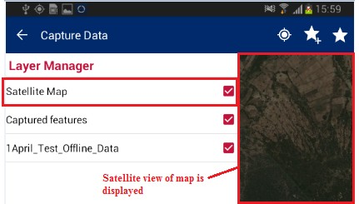

* + 1. Check the ‘Checkbox’ associated with layer
    2. Selected layer will become visible on map

## ZOOM TO CURRENT LOCATION

This functionality allows the user to navigate on the map to the current location.

**Steps:**

1.

Tap on ‘Zoom to current location' option

available on top right

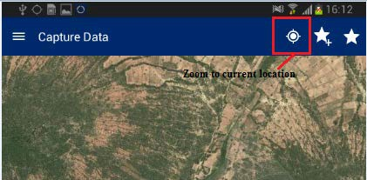

2.

Map will navigate to the current location

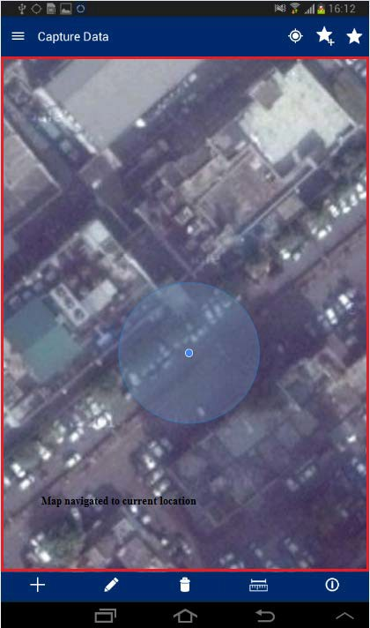

## ADD BOOKMARK

This functionality allows the user to save a particular area of interest of the map canvas for future reference.

**Steps:**

* + 1. Tap on ‘Add Bookmark’ option available on top right

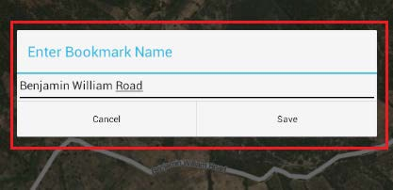

* + 1. ‘Enter Bookmark Name’ dialogue box will be displayed
    2. Enter desired name in input box and click on ‘Save’ button
    3. Bookmark will be saved with entered name and will become available in ‘Select Bookmark’ dialogue

## VIEW BOOKMARK

This functionality allows the user to navigate to a selected bookmark.

**Steps:**

* + 1. Tap on ‘View Bookmarks’ option available on top right

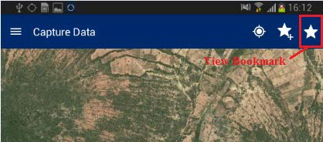

* + 1. ‘Select Bookmark’ dialogue box will be displayed with list of all bookmarks available.

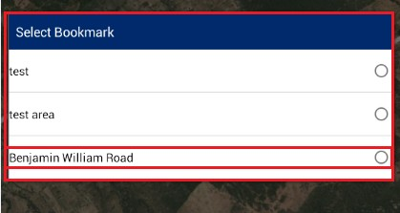

* + 1. Select required bookmark
    2. Map will navigate to the location saved with selected bookmark

## ADD FEATURE

This functionality provides multiple tools to capture spatial data on the map. These tools are point, line, and polygon. These features can be created via ‘manual drawing’ or via GPS.

**Steps:**

* + 1. Tap on ‘Add Feature’ option available on bottom tool box

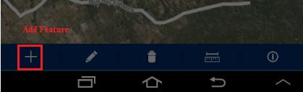

* + 1. 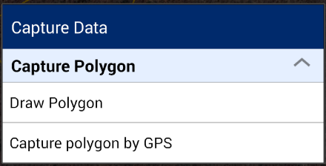‘Capture Data’ dialogue box will be displayed with following options:
       - Draw Polygon
       - Capture polygon by GPS



### DRAW POLYGON

This functionality allows the user to draw a polygon on the map manually by clicking on desired locations on the map.

* + - * 1. Select the option ‘Draw Polygon’
        2. Click on map. On first click, first vertex of the polygon will be created
        3. Next, click on second, third or more locations on map to create polygon
        4. Markers will be placed on clicked locations and polygon will be created
        5. Click on ‘Save’ option available on top right
        6. Polygon placed on map will be saved and ‘Capture Attribute’ form will be displayed

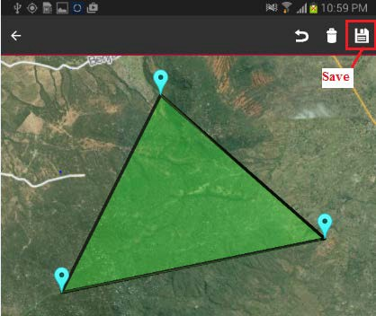

### CAPTURE POLYGON BY GPS

This functionality allows the user to draw a polygon covering selected locations using GPS.

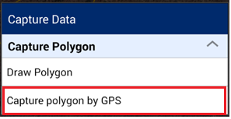1.

Select the option ‘Capture Polygon by GPS’

Click on ‘Plot point by GPS’ option available on top left

Marker will be placed on current location using GPS Move the device to second location and click on ‘Plot point by GPS’

Marker on second location will be placed on current location using GPS

Move the device to third or more locations and click on ‘Plot point by GPS’

Marker will be placed on current location using GPS and a polygon will be created

Click on `Save’ option available on top right

Polygon placed on map will be saved and ‘Capture Attribute’ form will be displayed

2.

3.

4.

5.

6.

7.

8.

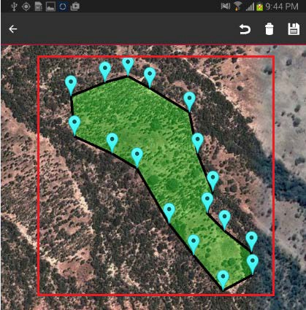

### SNAPPING

When drawing new polygon either by using GPS or clicking on the map, snap feature can be used to improve quality of collected data. By default snapping feature is enabled and parcel vertices will be displayed, helping with snapping. Snapping settings and labeling can be customized in the User Preferences menu, available on the homepage screen. In order to snap to the neighbor parcel, follow these steps:

* + 1. Long press on the marker of the captured polygon
    2. Drag the marker to the neighbor parcel vertex or line
    3. The marker will become green, indicating that it is snapped

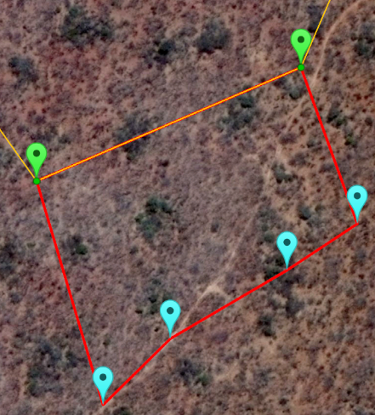

**Note: If you want to see neighbor parcel vertices (green points), you have to zoom in closer. Vertices will appear automatically, after certain zoom level. Vertices labeling have to be enabled as well (Map Settings of User Preferences).**

## CAPTURE ATTRIBUTES

Once spatial data is captured on the map, the user will be able to capture attributes and multimedia data for the spatial unit. Attributes that will be captured are configurable by the mobile configuration tool of the web application.

After creating the spatial data, a user clicks on the ‘Save’ option available on top left of screen.



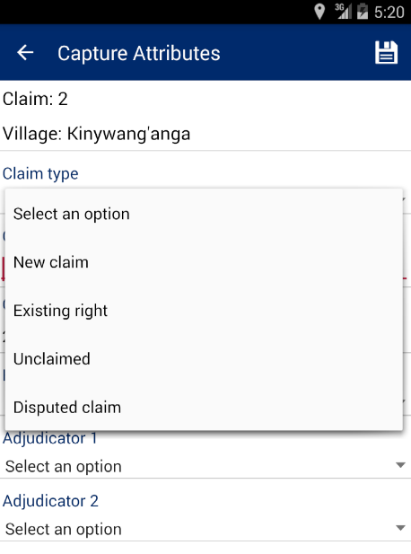After saving spatial data, Capture Attributes scree will appear, where user have to select the type of claim he/she wants to capture and provide other attributes.

The application allows capturing the following types of claim:

1. **New claim** – Most common type of claim, where new CCRO right will be registered.
2. **Existing right** – Any existing ownership right, discovered in the field. This type of claim will be further checked and verified by DLO. If information is correct, it will be included into the database as a digital record.
3. **Unclaimed** – Parcels, where no ownership rights were found, but the parcel can be clearly identified. Later this parcel can be claimed, but for the time being stays as unclaimed on the map.
4. **Disputed claim** – If any dispute discovered, it can be captured during field work.

Depending on the select type of claim, first screen and the following screens will look differently.



### New Claim

* + 1. After selecting ‘**New claim**’ on the first screen, the following fields have to be filled in/selected:
       1. Claim number – Manually assigned claim number. This number is written on the paper receipt, issued to the claimant for further reference to the claim. This number must be unique.
       2. Claim date – The date when claim was captured.
       3. Hamlet – Hamlet name, where claim is captured.
       4. Adjudicator 1 – Name of first adjudicator.
       5. 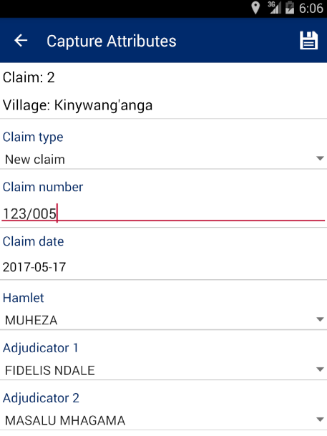Adjudicator 2 – Name of second adjudicator.

After finishing click on ‘Save’ option to proceed to Add Property Info screen.

* + 1. On the ‘Add Property Info’ screen, you have to provide the following information:
       1. Existing Use – Existing land use
       2. Land Type – Type of land
       3. Neighbor North – Name of neighbor from north side
       4. Neighbor South – Name of neighbor from south side
       5. Neighbor East – Name of neighbor from east side
       6. Neighbor West – Name of neighbor from west side

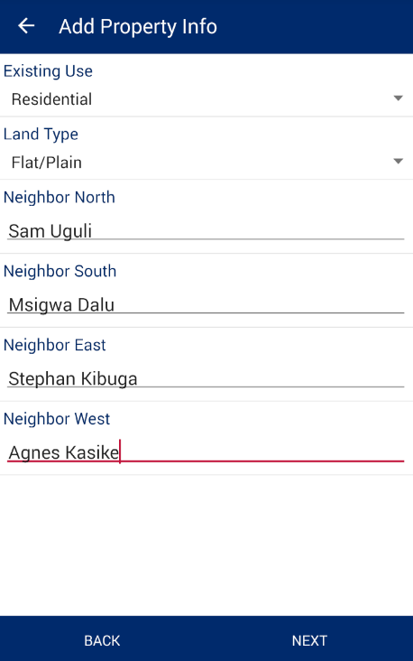

Once the data is entered, the user will then click on the ‘Next’ button. The application will save the property information and the ‘Add Social Tenure’ screen will be shown.

* + 1. On the ‘Add Social Tenure’ screen, the following details have to be provided:
       1. Type of Right – Captured type of right. For new Claims only ‘Customary Right of Occupancy’ is available. For Existing rights, ‘Certificate of Occupancy’ is available as well.
       2. Type of Tenancy – Sometimes called as share type and defines ownership structure (single, multiple, etc).
       3. Acquisition Type – The way an owner got this land.
       4. Length of Occupancy – Number of year an owner occupies/owns this land.
       5. Proposed Use – Proposed land use type.

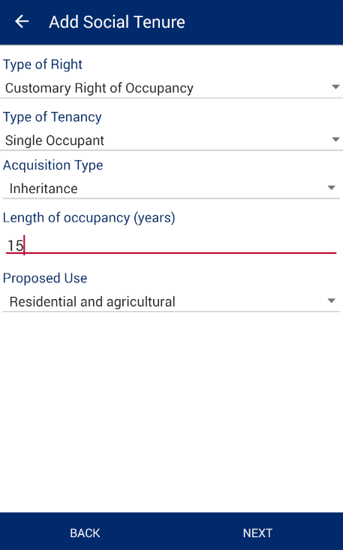

After providing all required information, user have to click ‘Next’ button to proceed to the next screen for capturing owner(s) details. Depending on the selected Type of Tenancy, different screen will be opened for capturing owners as well as different rules applied. There are 6 main types available for selection:

* + **Multiple Occupancy (Tenancy in Common):** If the user selects this tenure type and saves the form, then the user will be prompted to add users in the Add Person form. The user will be required to add two or more “*Owners*” and there can add one or more “*Person(s) of Interest*”.

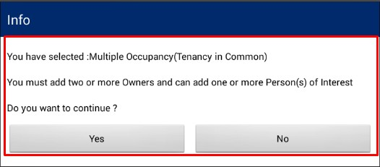

* + **Single Occupant:** If the user selects this type of tenure, and saves the form, then the user will be prompted to add users in the Add Person form. In this case, the user will be required to add only one “*Owner*” and will have the possibility to add one or more “*Person(s) of Interest*”.

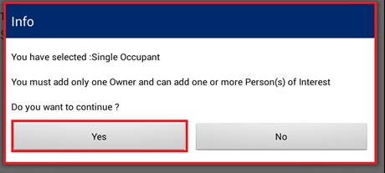

* + **Multiple Occupancy (Joint Tenancy):** If the user selects this tenure type, then the user will be prompted to add users in the Add Person form. In the Add Person form, the user will be required to add two “*Owners*” and may add one or more “*Person(s) of Interest.*”

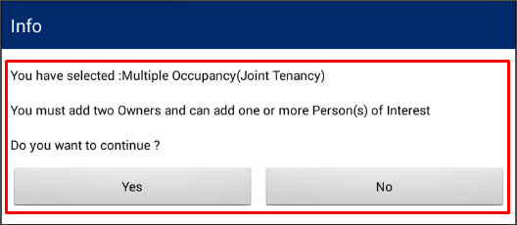

* + **Tenancy in Probate (Administrator):** If the user selects this tenure type, then in the Add Person form the user will be required to add one or more “*Owner(s)*”. Based on the tenure selection, the user may and up to two “*Administrators*” and will also need to indicate the name of the “*Deceased Person*”. The user can also add one or more “*Person(s) of Interest*.”

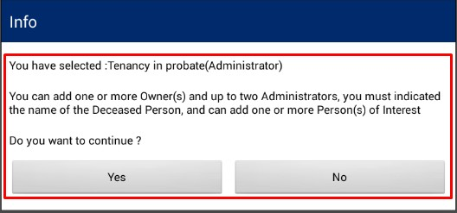

* + **Guardian (Minor):** If the user selects this tenure type, then the user will be prompted to add users in the Add Person form. The user will be required to add one or more “*Minor*” and up to two “*Guardian*”.

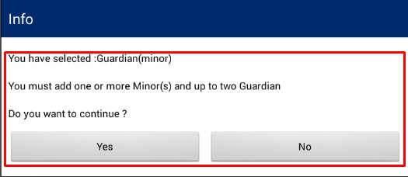

* + **Non-Natural/Institution:** If the user selects this tenure type, no info messages will be displayed and next screen will guide/control you about what information have to be provided.

**Note:** It is mandatory to add photo for Owner, Administrator and Guardian**.**

Based on tenancy type the user has selected, the user will be required to provide inputs available in ‘Person List’ form.

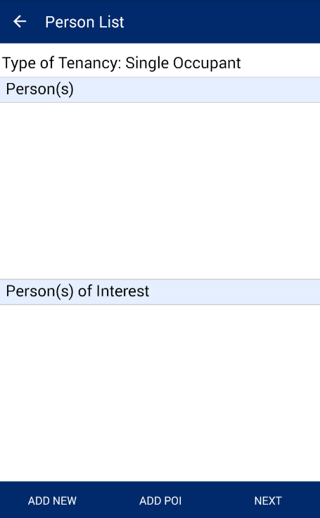

Follow the steps below to add persons and person of interest:

1. Click ’Add New’ button to add person.
2. Select person type and click ‘Save’

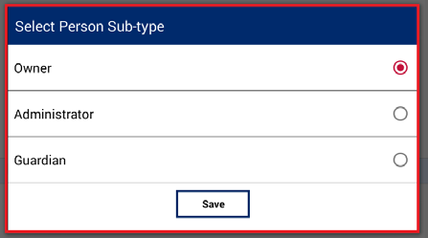

1. Click on ‘Add New’ button, ‘Person Sub-type’ dialogue will be displayed. Select the required option and click on ‘Save’ button.
2. ‘Add Person’ form will be displayed. User will enter the desired attributes and click on ‘Save’ button.

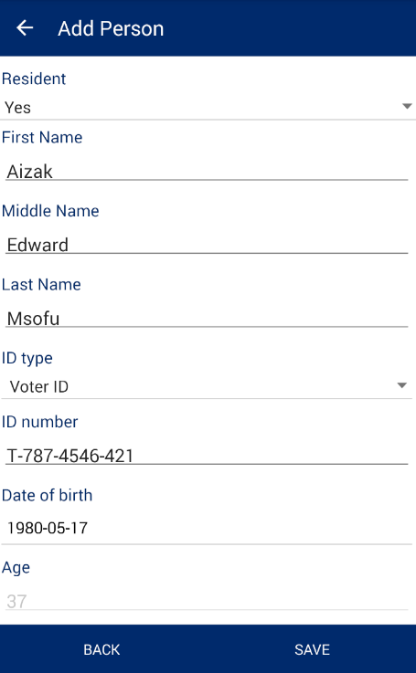

1. Personal details will be saved and details will become available in corresponding section.

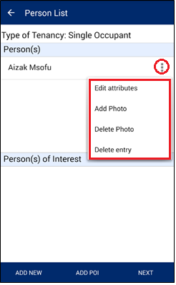

1. Click on option associated with record available in Person(s) section. The following options will be available:
   1. Edit Attribute
   2. Add Photo
   3. Delete Photo
   4. Delete entry

**Note:**

* **Edit Attribute: ‘**Edit Attribute’ option will enable user to edit the current details of person.
* **Add Photo:** ‘Add Photo’ will enable user to take a photo of the person and associate it with details.
* **Delete Photo:** ‘Delete Photo’ will enable the user to delete an existing photo.
* **Delete entry:** ‘Delete Entry’ will enable user to delete the person’s details.

1. Click on ‘Add POI’ button. ‘Add Person of Interest’ dialogue will be displayed. Provide the required details and click on ‘Save’ button.

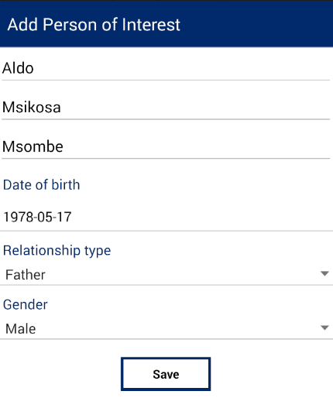

**Note:** Only first, last and middle name are required. Date of birth, relationship type and gender fields can be omitted.

1. Details of ‘Person of Interest’ will be saved and details will become available in corresponding section.
2. Click on option associated with record available in ‘Person(s) of Interest’ section, following options will be available:

* **Edit**. ‘Edit’ option will enable user to edit the current details of the person of interest.
* **Delete Entry**. ‘Delete Entry’ will enable user to delete the person’s details.

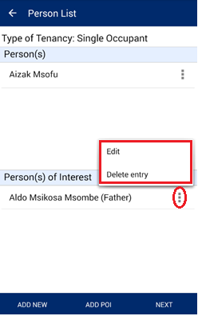

1. Once you’ve finished with adding persons and persons of interest, click ‘Next’ button to proceed to the ‘Multimedia List’ screen.
2. On the ‘Multimedia List’ screen you can add different types of documents, supporting this claim. Documents are added by taking their photo and providing additional information. The most common case is to take picture of the claimant’s ID. Nevertheless, multimedia list is an optional and can be skipped.

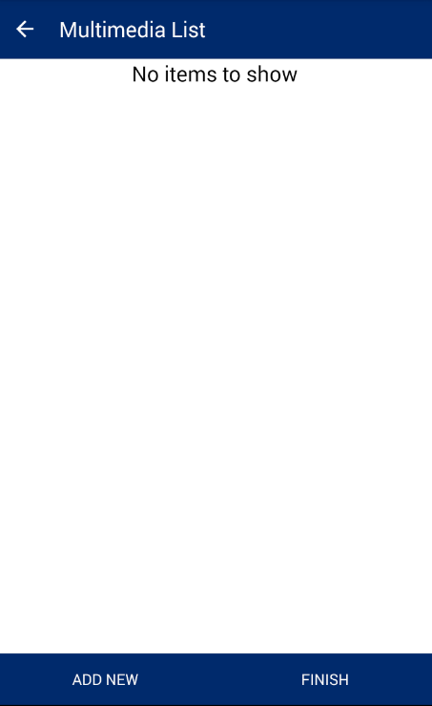

1. For adding new document, click ‘Add New’ button and select ‘Image’ option.

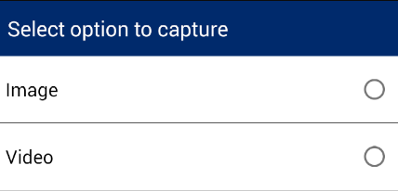

1. You camera will be automatically activated for taking snapshots. Take a picture of a document and click accept button (V).
2. New screen will appear to provide document description. You can provide the following information:
   1. Document type
   2. Name
   3. Comments.

You are required to select at least document type.

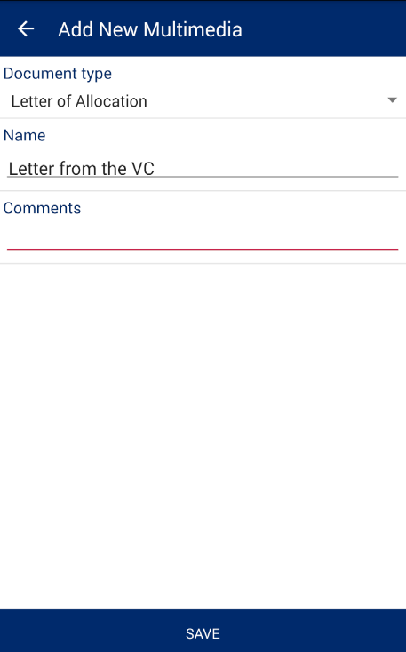

1. After you’ve entered document description, click ‘Save’ button to save it into multimedia list.

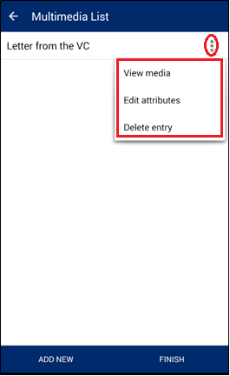

1. By clicking on the options button (…) you can review document, edit its attributes or delete it.
2. In order to finalize capturing new claim, click ‘Finish’ button.
3. If custom attributes were defined for specific project, next screen will show the list of additional attributes, which have to be provided, otherwise you will get on the summary screen. On the final screen you can review summary information and either close it by clicking ‘Close’ button or come back to editing attributes by clicking ‘Edit Attributes’ button.

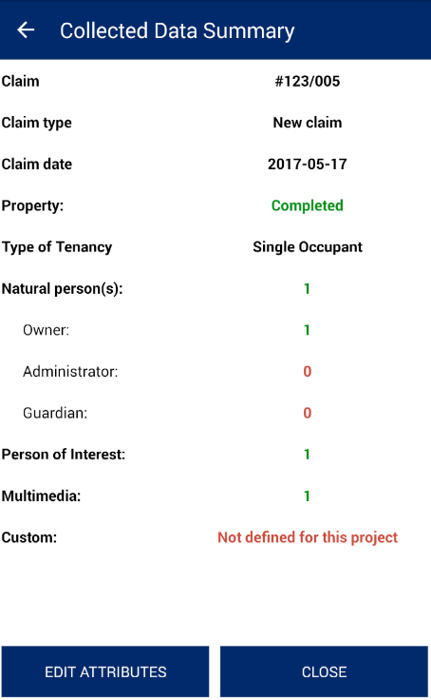

### Existing Right

Capturing existing right claims is very similar to the capturing new claims. Few extra fields will be needed for existing rights. Follow the steps bellow to complete existing rights capturing:

* + - 1. Start data capturing as described in 9.5
      2. Upon saving demarcated parcel, ‘Capture Attributes’ screen will popup.
      3. Select ‘Existing Right’ option from the dropdown list of claim types.
      4. Apart from the fields, you fill in for new claims, there will be one more field, you have to provide - ‘UKA/Farm/Plot Number’. Depending on the type of existing right, it can be UKA number, Farm number of Plot Number.

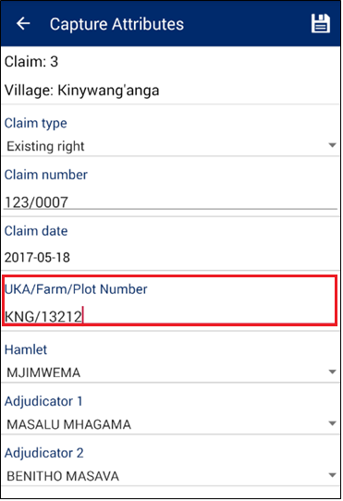

* + - 1. Click ‘Save’ icon to proceed to ‘Add Property Info’ screen, which has no difference to the new claim capturing. Refer to the section 9.6.1 for more details.

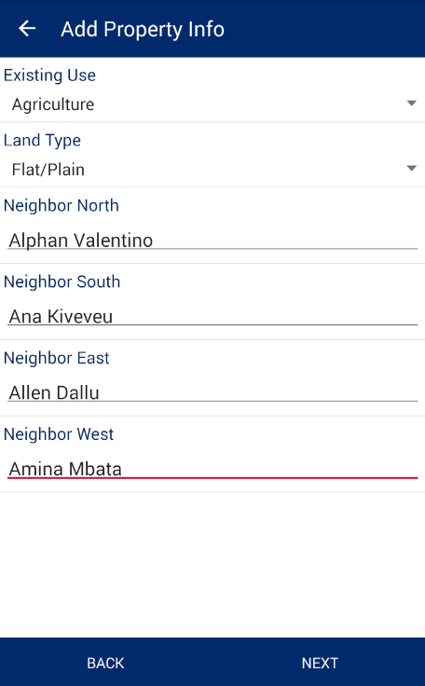

* + - 1. Click ‘Next’ button to go to ‘Add Social Tenure’ screen. On this screen, compared to the new claim capturing, you can select different type of right and you have to provide the following extra details:
         1. CCRO/Title number – Registered CCRO or title number of existing right.
         2. CCRO/Title date – Date when CCRO or title was registered.
         3. Juridical area – Juridical area of the parcel, written in the CCRO or title.

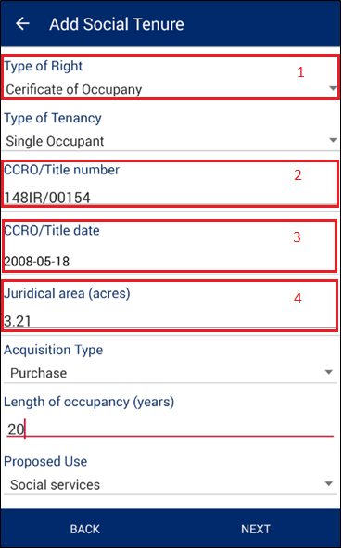

* + - 1. After providing all required data, click ‘Next’ button to capture person details.
      2. Refer to the section 9.6.1 for more details on ‘Persons List’ screen and the following ‘Multimedia List’.

### Unclaimed

Unclaimed parcel is the simplest type of claim and doesn’t require providing most of the fields. Follow the steps bellow to capture Unclaimed:

* + - 1. Start data capturing as described in 9.5
      2. Upon saving demarcated parcel, ‘Capture Attributes’ screen will popup.
      3. Select ‘Unclaimed’ in the ‘Claim type’ field and fill in/select other fields.

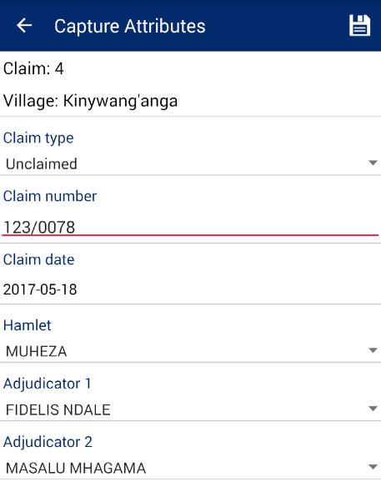

* + - 1. Click ‘Save’ icon to finalize claim. No other details are needed and you will get on the summary screen.

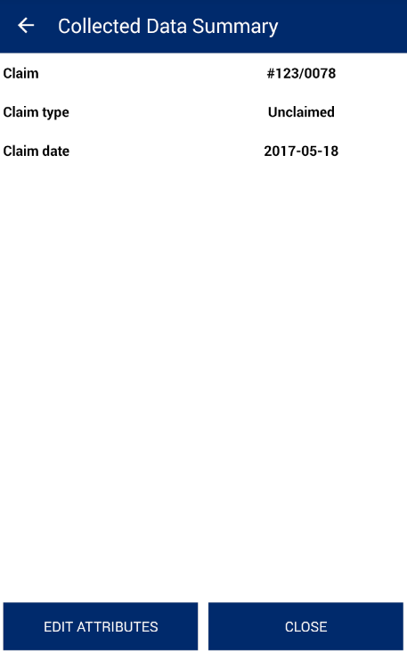

### Disputed Claim

Disputed claim type allows you to register different types of disputes, found during the field work. Complete the following steps to register new dispute:

* + - 1. Start data capturing as described in 9.5
      2. Upon saving demarcated parcel, ‘Capture Attributes’ screen will popup.
      3. Select ‘Disputed claim’ in the ‘Claim type’ field and fill in/select other fields.

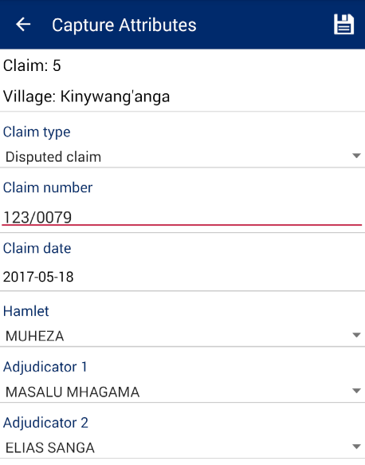

* + - 1. Click ‘Save’ icon to proceed to ‘Add Property Info’ screen, which has no difference to the new claim capturing. Refer to the section 9.6.1 for more details.

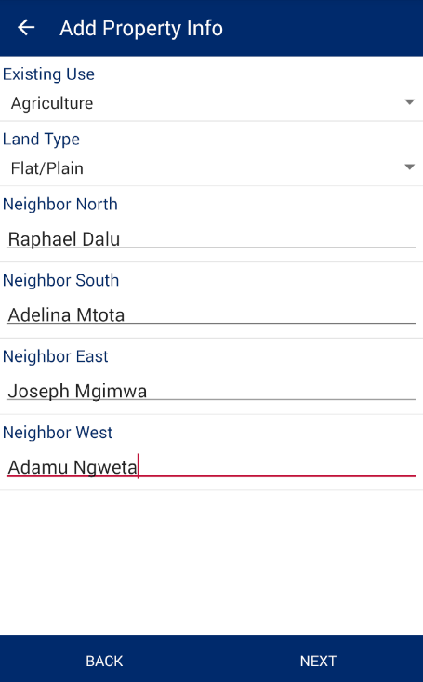

* + - 1. Once property information is provided, click ‘Next’ button to go to the ‘Dispute Details’ screen.
      2. On the ‘Dispute Details’ screen you have to provide the following information:
         1. Dispute type
         2. Dispute description
         3. Disputants (at least 2)
      3. Use ‘Add Person’ button to add disputants. Comparing to the other ‘Add Person’ screens, you will have to provide one more extra field - ‘Acquisition Type’.

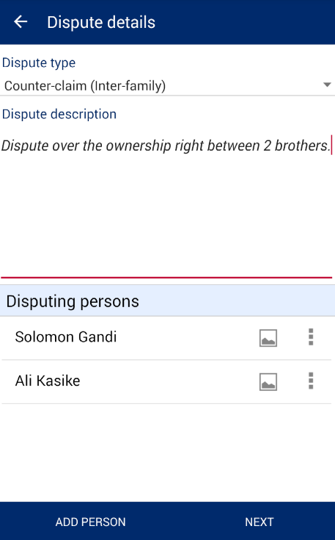

* + - 1. After you have provided dispute details, click ‘Next’ button to go to the ‘Multimedia List’ screen.
      2. On the ‘Multimedia List’ screen you can add any optional evidences (documents), confirming disputants’ rights. Refer to the section 9.6.1 for more details on adding documents.

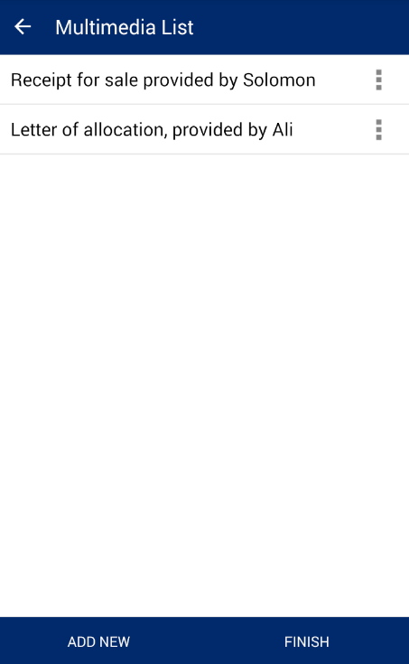

* + - 1. Click ‘Finish’ button to finalize capturing the dispute.

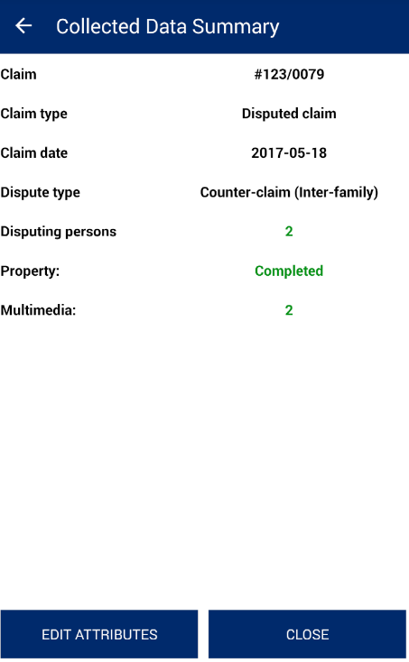

## EDIT SPATIAL

This functionality allows the user to edit spatial data which has already been captured by the user.

**Steps:**

* + 1. Click on ‘Capture Data’ option available on home page

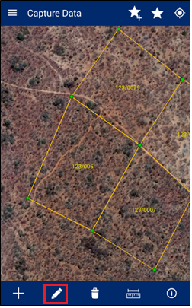

* + 1. Navigate to parcel which is being edited
    2. Click on ‘Edit Spatial’ data icon
    3. Click on feature to be edited
    4. 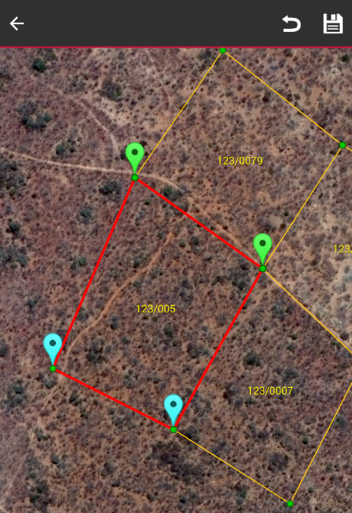Application will show nodes/vertices in editable format
    5. Select node/vertices by long pressing the node/vertices and move these
    6. You can use snapping feature to snap to the neighbor parcel vertices and lines. When edited vertex get snapped, it will be displayed in green color.
    7. 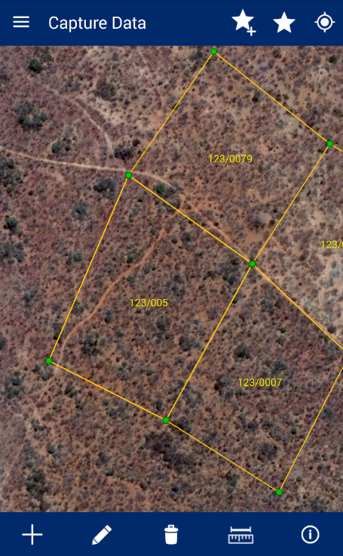Click on ‘Save’ on right top
    8. Application will save updated spatial features and an acknowledgement message will display

**Note:** In case feature is not visible, click on back arrow

button on left hand top of screen. Click on

‘Capture Spatial’ data icon. Application will open up

Layer Manager. Switch on the Captured Features layer.

## DELETE FEATURE

This functionality allows the user to delete spatial data.

**Steps:**

1.

Click on Delete icon

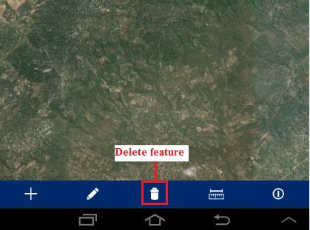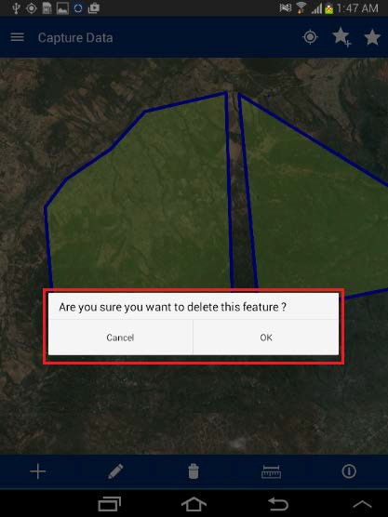

2.

Click on the created spatial feature

The application will display a confirmation message to the user: “Are you sure you want to delete this feature?” with ‘Ok’ and ‘Cancel’ option

Click on ‘Ok’ button

3.

4.

5.

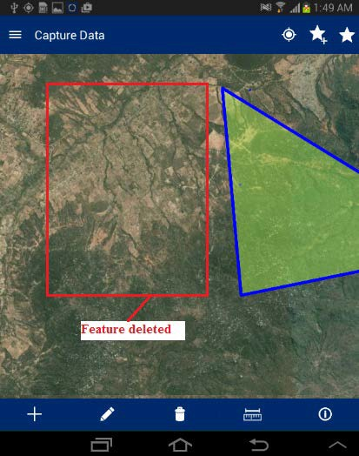

Application will delete the selected feature and

same will not be visible in the map

# REVIEW DATA

This functionality allows the user to view the data collected in the field for review and finalization. This also allows the user to Edit Special, Edit Attribute, Delete Entry or mark a parcel as Complete.

**Steps:**

* 1. Click on ‘Review Data‘ option available on Home page

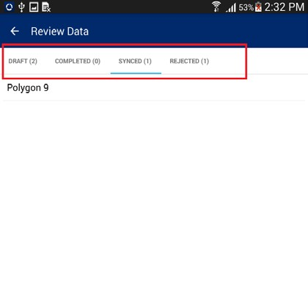

* 1. ‘Review Data’ form will be displayed with following lists
     + **Draft –** Parcels that are not marked as complete will be listed in ‘Draft’ list
     + **Completed –** Parcels that are marked as complete will be listed in ‘Completed’ list
     + **Synced –** Parcels that have been synced will be listed in ‘Synced’ list
     + **Rejected –** Parcels that are rejected from the back-end web application, will be listed in the ‘Rejected’ list

## DRAFT LIST

A parcel that is not marked as completed will be listed in ‘Draft’ list. The user can perform the following actions on parcels available in Draft List:

* + - Edit Spatial
    - Edit Attribute
    - Delete Entry
    - Mark as Complete

**Steps:**

1.

Click on the ‘Action’ option available with the

parcel record in the ‘Draft List’

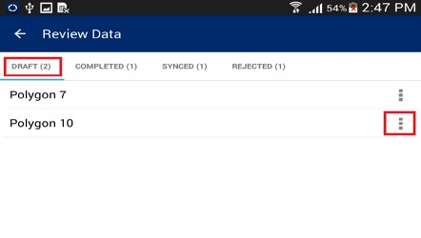

2.

A list of available possible actions will be

displayed

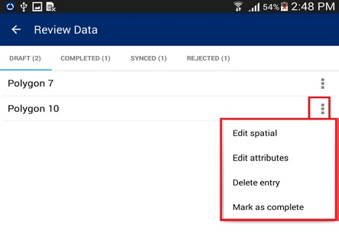

### EDIT SPATIAL

This functionality allows the user to perform editing on spatial data.

**Steps:**

1.

Select the ‘Edit Spatial’ option

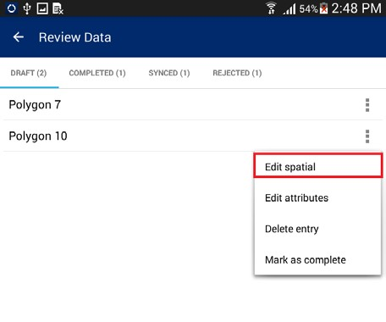

2.

User will navigate to map and the

corresponding feature will be available in edit mode.

Select node/vertices by long pressing the node/vertices and move the same.

Click on ‘Save’ option

Application will save updated spatial feature.

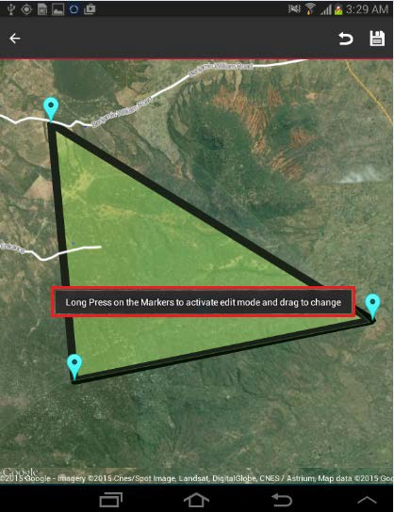

3.

4.

5.

**Note:** In case feature is not visible, click on back arrow button on left hand top of screen. Click on Capture Spatial data icon. Application will open up Layer Manager. Switch on Captured Features layer.

### EDIT ATTRIBUTE

This functionality allows the user to edit attribute data for the spatial unit.

**Steps:**

1.

Click on ‘Edit Attribute’ option

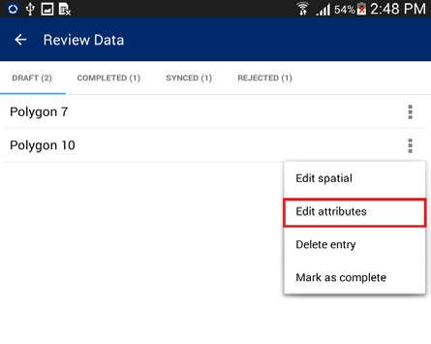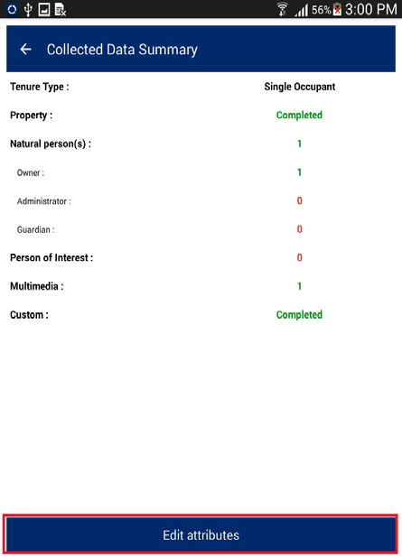

2.

User will navigate to ‘Collected Data

Summary’ form. This will display the

summarized details of the survey. There will be a button ‘Edit Attribute’

* 1. Click on ‘Edit Attribute’ button

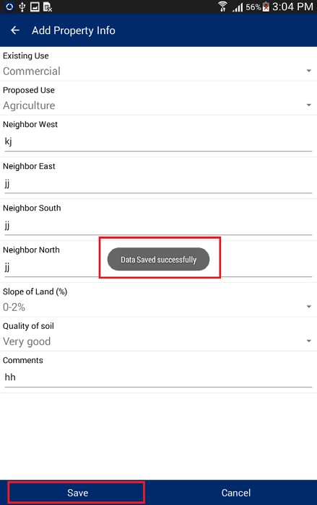

* 1. User will navigate to ‘Capture Attribute’ form and attributes of corresponding feature will be available in edit mode
  2. Edit required attributes
  3. Click on ‘Save’ option
  4. Application will save updated attribute details and an acknowledge message will be displayed

### DELETE ENTRY

This functionality allows the user to delete a spatial unit along with all of its attribute data.

**Steps:**

* + - 1. Click on ‘Delete Entry’ option

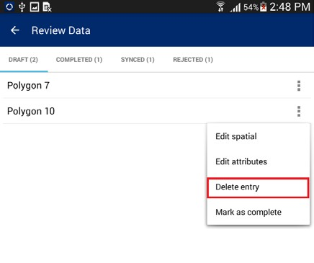

* + - 1. Application will display a confirmation message along with ‘Cancel’ and ‘OK’ button
      2. Click on ‘OK’ button

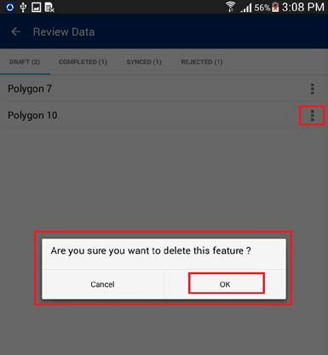

* + - 1. Corresponding feature along with its attribute details will be deleted

### MARK AS COMPLETE

This functionality allows the user to mark a parcel complete. Once a parcel is completed it can be synchronized.

**Steps:**

* + - 1. Click on ‘Mark as Complete’ option

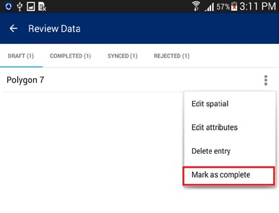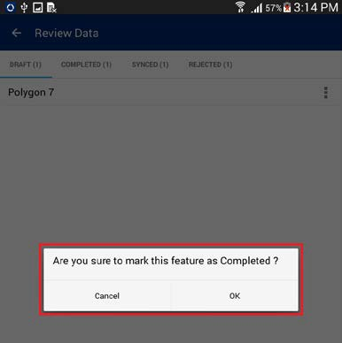

* + - 1. Application will display a confirmation message along with ‘Cancel’ and ‘OK’ button
      2. Click on OK button
      3. Parcel will be completed. It will be removed from ‘Draft’ List and will become available in the ‘Completed’ List

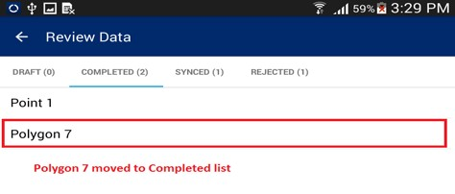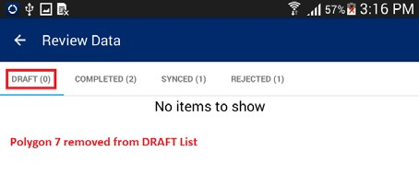

# UPLOAD DATA

This functionality allows the user to submit completed and verified data to the back-end cloud server.

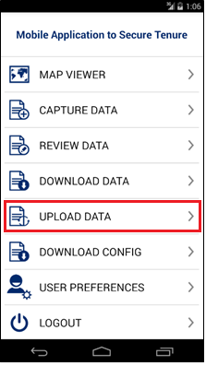**Steps:**

* 1. Click on the ‘Upload Data’ option available on the Home page
  2. Application will connect to the remote server to upload data
  3. 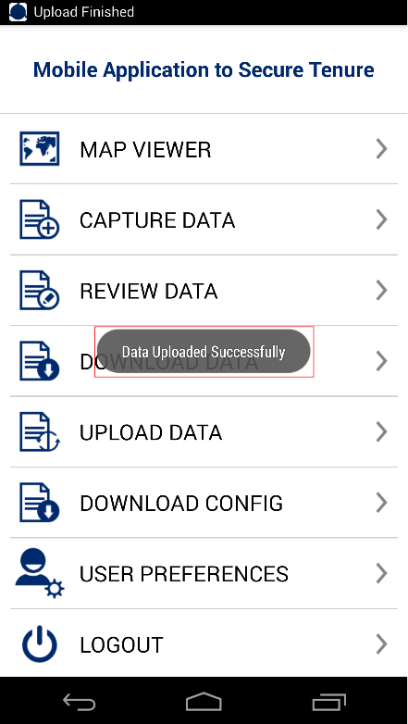Once Data uploading is completed, an acknowledgement message will be displayed

# USER PREFERENCES

This functionality allows the user to change settings for the MAST mobile application. This functionality also allows the user to change default language, configure data collection tools, configure sync up and map display.

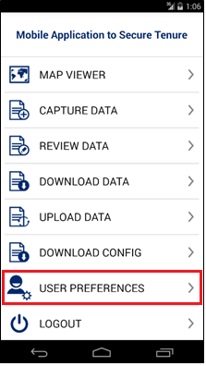

**Steps:**

* 1. Click on ‘User Preferences' option available on the Home page.

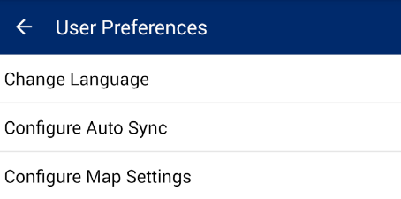

* 1. User Preferences for will be displayed with following options:
     + Change Language
     + Configure Auto Sync
     + Configure Map Settings

## 11.1 CHANGE LANGUAGE

This functionality allows the user to change to a preferred language for the mobile application.

**Steps:**

1. Click on ‘Change Language’ option
2. Application will display ‘Change Language’ dialogue
3. Select desired language
4. Click on OK button, language of the MAST application will be changed

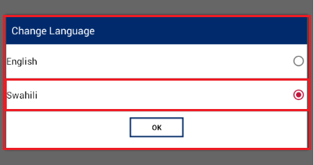

Forms has been changed to Swahili:

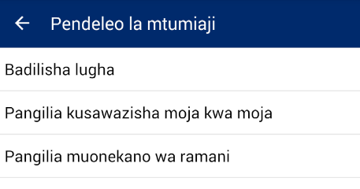

## CONFIGURE AUTO SYNC

This functionality allows the user to configure the sync up settings on the device. Users can configure sync up to be 'Auto Sync'. Auto Sync means that the data will be synced automatically to the back-end server whenever internet connectivity is available.

**Steps:**

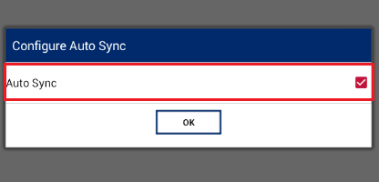

1. Click on ‘Configure Auto Sync’ option
2. ‘Configure Auto Sync’ dialogue box will be displayed
3. Check ‘Auto Sync’ option, if user wishes to enable auto sync up
4. Click on OK button

## CONFIGURE MAP SETTINGS

This functionality allows the user to configure snapping settings and displaying of labels, when viewing the map or capturing data.

**Steps:**

1. 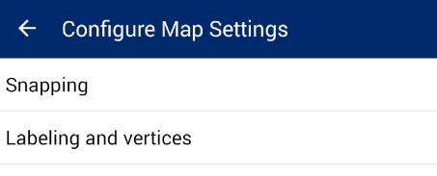Click on ‘Configure Map Settings option
2. ‘Configure Map Settings’ form will be displayed with the following options:
   * Snapping
   * Labeling and Vertices

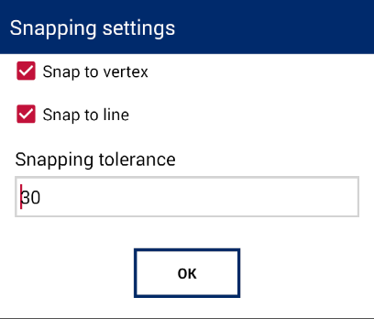

### 11.3.1 SNAPPING

This functionality of snapping objects and snapping tolerance. The following settings can be configured:

* + - 1. **Snap to vertex** – Enables snapping to the parcel vertices
      2. **Snap to line** – Enables snapping to the parcel sides (lines)
      3. **Snapping tolerance** – Distance in screen pixels, when automatic snapping should occur to the snapping objects (vertex, line).

### LABELING AND VERTICES

These settings allow configuration of displaying vertices and labels when viewing and editing map. The following options are available:

* + - 1. **Enable labeling** – Enables displaying of parcel labels. If claim number is provided, it will be used as a label, otherwise word “Polygon” + sequential number will be used (e.g. Ploygon 20).
      2. **Enable vertex drawing** – Enables drawing/showing vertices of parcels, when in the editing or data capture mode.

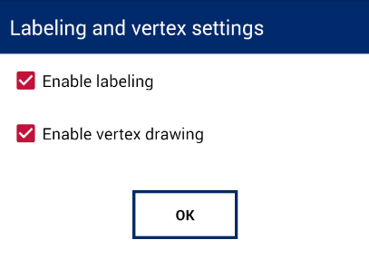

**Note**: Labels and vertices will be displayed after certain zoom level. This is done to improve the performance of the map component. If labels and/or vertices enabled for displaying, but you don’t see them, try to zoom in closer.

# 12. LOGOUT

This functionality allows the user to logout from the application. When the user clicks on the logout option, if any of the completed parcel is pending for sync up, the application displays a notification message.

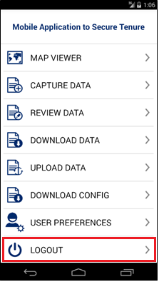

**Steps:**

1.

Click on ‘Logout’ option available on Home

page

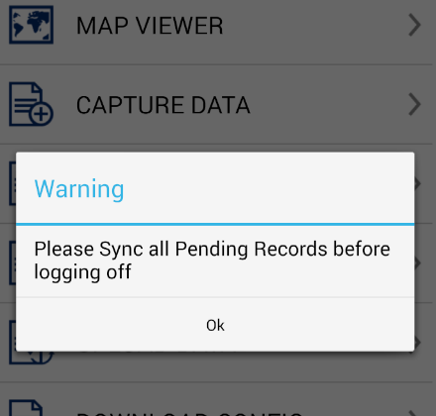2.

If any of the completed parcel is pending for

uploading, the application displays a Warning message

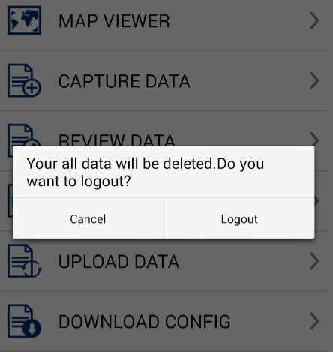

3.

If there is no pending parcel for uploading, the application displays a Warning message

4.

Click on Logout button. The user will be logged out from the application.

Mobile Application to Social Tenure Pilot Project (MAST) 67

User Manual for the Mobile Application

U.S. Agency for International Development 1300 Pennsylvania Avenue, NW

Washington, DC 20523

Tel: (202) 712-0000

Fax: (202) 216-3524

[www.usaid.gov](http://www.usaid.gov/)